**ERP SIMULATOR**

# **PROJECT DESCRIPTION**

 Simulator to integrate all the functional departments in an enterprise. It helps the corporate management team to understand the market demands by integrating the departments through decision making and providing the reports. A user first has to sign-up himself as a consumer or as a producer. Once registered, a consumer can log-in to place an order from the products provided by the organization. The producer sees the order, checks if any resources are already present in the inventory and manufactures the product.

                 A consumer can create, modify or cancel an order and can also check for the status of a placed order. A producer gets to know the list of tasks to be performed for completing an order and can update the order status. Producer can also add products to the inventory whenever there is surplus or if an order is being cancelled after the product is completed. The integration unit integrates parameters which determines the efficiency of order completion. Admin generates the reports of the enterprise based on the data generated from the integration unit.

The loosely coupled application will be an automatic order cancelling application. Sometimes the organization receives an order for a service it does not provide or if an order does not get placed in due time, then it will be terminated by this application and producer cannot see the order once it is closed.

**NOUNS AND VERBS**

**Nouns**- simulator, departments, enterprise, corporate management team, market demands,reports,user,consumer,producer,order,products,organization,producer,resources,inventory, status, surplus, integration unit, parameters, efficiency, automatic order cancellation, admin, data.

**Verbs**- integrate, helps, understand, decision making,providing,sign-up,registers,log-in,place,provided,sees,checks,present,manufactures,create,modify,cancel,view,add,update,completed,generates,terminated.

**CONSOLIDATED NOUNS AND VERBS**

**Consolidated Nouns**

**Admin**: refers to the administrator of the enterprise

**Producer**:  produces the products based on order of customer

**Consumer**: places an order

**Product**: final product produced by producer and delivered to the consumer who placed the order

**Order**: placed by the consumer

**Task**: work done by the producer

**Inventory**: keeps stock of surplus goods produced

**Integrationunit**:  integrates the consumer, producer, order, inventory and product

**Clean**: loosely coupled component

**Consolidated Verbs**

**Sign up**: registering for the site  
**Log-in :**signing into the system

**Create :**creating an order

**Modify :**modifying an order

**Cancel :**cancelling an order

**View**: view the order status

**Manage**: manage the inventory

**Update**: update the order status

**Generate**: generate report by admin

**Terminate**: closing a bad order

**CLASSES AND RESPONSIBILITIES**

**Admin**: Contains information about admin identifier, password and user type.  Responsibility is to view the integration unit and generate reports.

**Producer**: Contains information about producer identifier, password and user type. Responsibilities include register, log-in, view cart, manage inventory and update order status.

**Consumer**: Contains information about consumer identifier, password and user type. Responsibilities include register, log-in, place order, modify order, cancel order and check order status.

**Order**: Contains information about the order date, order status, order quantity and order identifier. Responsibilities include viewing order and creating order.

**Product**: Contains information about the product name, unique product identifier, product description and product quantity. Responsibilities include changing in database when new product is produced and delivered.

**Inventory**: Contains information about the item name, item identifier and excess quantity. Responsibilities include adding product and updating product.

**Task**: Contains information about  task description.  Responsibility is to maintain the integration unit and generate reports.

**Integrationunit** : Contains unique identifiers of products and orders . Responsibilities include generating the report.

**Cleanup** : Contains information about orders that have been closed without completion. The responsibility is terminating the order.

## **Class Diagram**

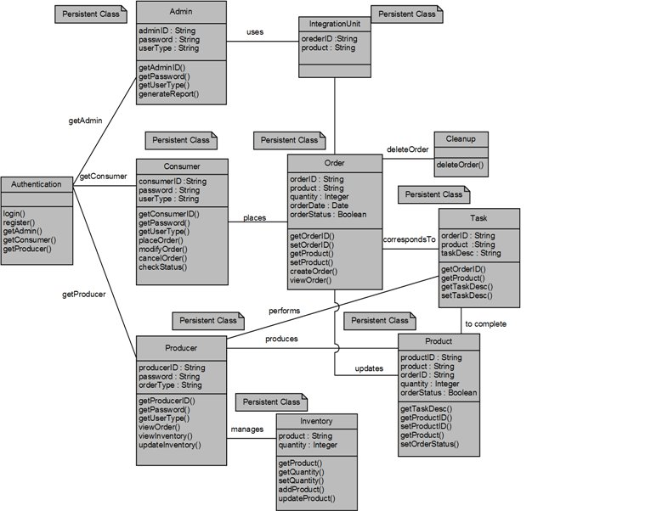

# **Use Cases**

**Admin** shall be able to:

1. Logs into application

Admin can log into the system based on the username and password provided.

1. View the Integration Unit

View the various order details and product details maintained in the integration unit.

1. Generate reports

Generate the reports which will depict the corporate demand supply chain process and which can be used for further business analysis and forecasting.

**Consumer** shall be able to:

1. Registers in the application

A new consumer to the application can register for an account using their ConsumerID. The registration is then validated. Consumer is automatically logged into the system upon successful registration.

1. Logs into application

An existing producer can log in to the application using their ConsumerID and the

Password they set during registration.

1. Place the order

Place an order of the desired product.

1. Modify the placed order

Modify an existing order.

1. Cancel the order

Cancel an order.

1. Enquire about the placed order status

Check the current status of an order being processed and ensure completion of the order before the deadline.

**Producer** shall be able to:

1. Registers in the application

A new producer to the application can register for an account using their ProducerID. The registration is then validated. Producer is automatically logged into the system upon successful registration.

1. Logs into application

An existing producer can log in to the application using their ProducerID and the

Password they set during registration.

1. View the cart of placed order

View the list of the orders placed by the Consumer and also ensure completion of orders on time.

1. Check for the tasks to be performed to complete an order

To follow the process required for the completion of each order.

1. Update the status of received order

Compare the current status of a product to that of the task list and updates the order status on a periodic basis.

1. Manage the Inventory

Check the inventory whenever a new order is placed for availability of products and also update the inventory whenever the order is being cancelled.

# **Non-Functional Requirements**

We will be focusing mainly on two non-functional requirements in our project.

* One is Maintainability. Our goal is to have all the coding and design procedures stick to professional standards and enable easy modifications in the code and code reusability in the future. The Architectural standards are also to be strictly followed as per requirements without any deviations.
* The second non-functional aspect of the application will be Usability.

For usability this application will have intuitive user interaction on all of the pages in the application. We will use simple user interface enabling easy use of the application and also provide user guidance wherever necessary.

Process descriptions result in the main requirements of the ERP system.

# **Database Schema**

